**Health-Insurance => Co-Insurance (Type of Insurance)**

Ex. 1) Shubham -> Admit -> Billing Amount 20,000/- -> Co-Insurance -> 20% Policy Holder + 80% Insurance Company

-> 4000 Policy Holder + 16000 Insurance Company

Ex. 2) Shubham -> Admit -> Billing Amount 30,000/- -> Co-Insurance -> 5000 Policy Holder + 25000 Insurance Company

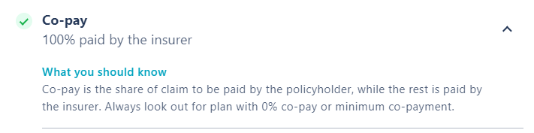

Medicine

Doctor charge

Nurse

Bed charges

Room charges

Injection

Gloves

Syringe

3.5 yrs Experience

1. Crypto Domain -> 2 yrs -> Recent
2. HealthCare Domain -> 1.5 yrs -> Previous
3. Crypto Domain ->1 yrs -> Previous
4. HealthCare Domain -> 2.5 yrs -> Recent

**SQL ->** MySQL, SQL Server, SQL Developer, PostgresSQL, Oracle SQL

**NoSQL ->** Cassandra, MongoDB

**Browsers ->** Google Chrome, Mozilla Firefox, MS Edge, Safari, Opera, Brave

**Version Control ->** Virtual Box, Browser stack, Lamda Test, VM ware